**Citi Bank Bike Analysis**

With the help, Professor Booth, we were able to compile the 2019 Citi Bank Bike Trip History.

1. My favourite dashboard, “Bike Stations, Ranked by Popularity (Descending)”. The data shows that certain parts of the city are a tourist destination. The “Popular Start” and “Popular End” station also have a higher income relative to the rest of the city.

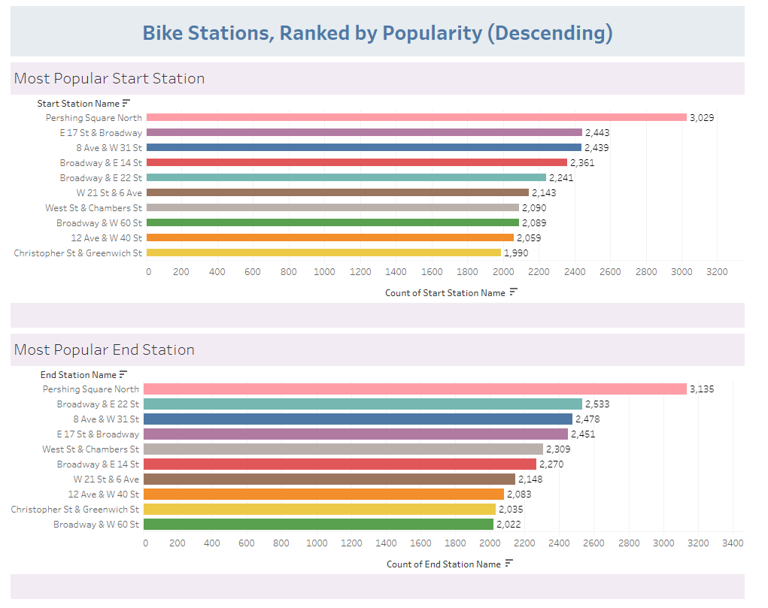

1. Citi Bank invested across the entire city of New York allowing for efficient use as well as cost optimizations. By allowing users to drop their bike almost anywhere, Citi Bank Bike program has a higher probability of use.

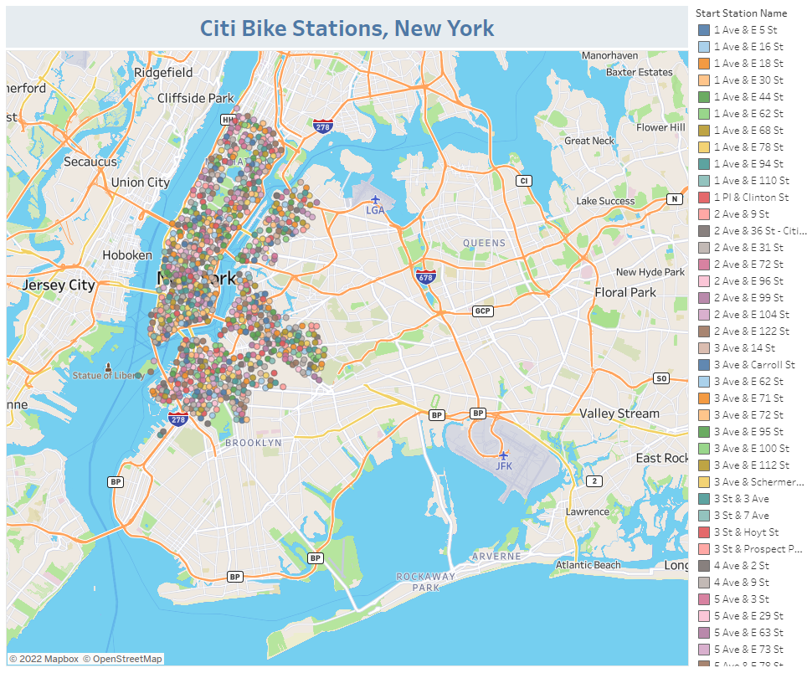

1. Male riders are higher than users than female riders. In this case, during vacations men tend to set up the account of such leaving our wives to just pick the bike. As a man, I am more like to set up the account to use the bike program for my wife and I. There are more subscribers than users, I assume that there is a discount to be a subscriber so users will sign up as subscribers and forget about their Citi Bike account.

